Create a container in active mode using the default user account, with a binded data directory:



Create a production container with a custom user account, binding a data directory and enabling both active and passive mode:

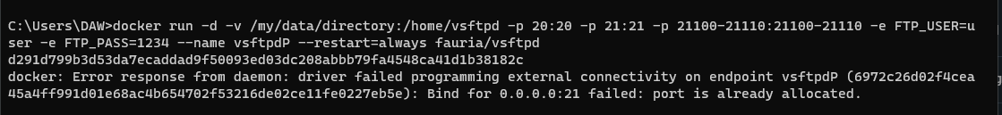

Manually add a new FTP user to an existing container:

